Employee Vacation Tracker

<version 1.0>

Table of Contents

- Purpose
- Functional Requirements
- High level Design
- Technical Design

- Purpose

The main objective of the Employee vacation request tracker is to manage the details of leave, absence requests, holidays, leave balances. The main purpose of the project is to build an application program to reduce the manual work for leave management. The application ensures all the leave requests are formalized and properly tracked. Also managers and HRs will get up to date information to approve a leave request.

- Functional Requirements
- Vacation tracker system should have following features
- Employee can Login to the system through first page of the application
- view his/her leave balances
- view absence history since the time he/she joined
- request absence , specifying the to and from dates, reason for leave
- Approve/Reject leave options for mangers/HR
- Withdraw the leaves which are not approved yet
- Once the leave request is raised, a notification email should be sent automatically to the employee and the supervisor. They will be provided by a link in the email to approve/reject the request. Once the action is completed, a mail will be triggered to the Employee to view status.
- The number of leave days should credited to everyone during the starting of a year. Once the request is raised, leave balance should be updated automatically.

- High Level Design

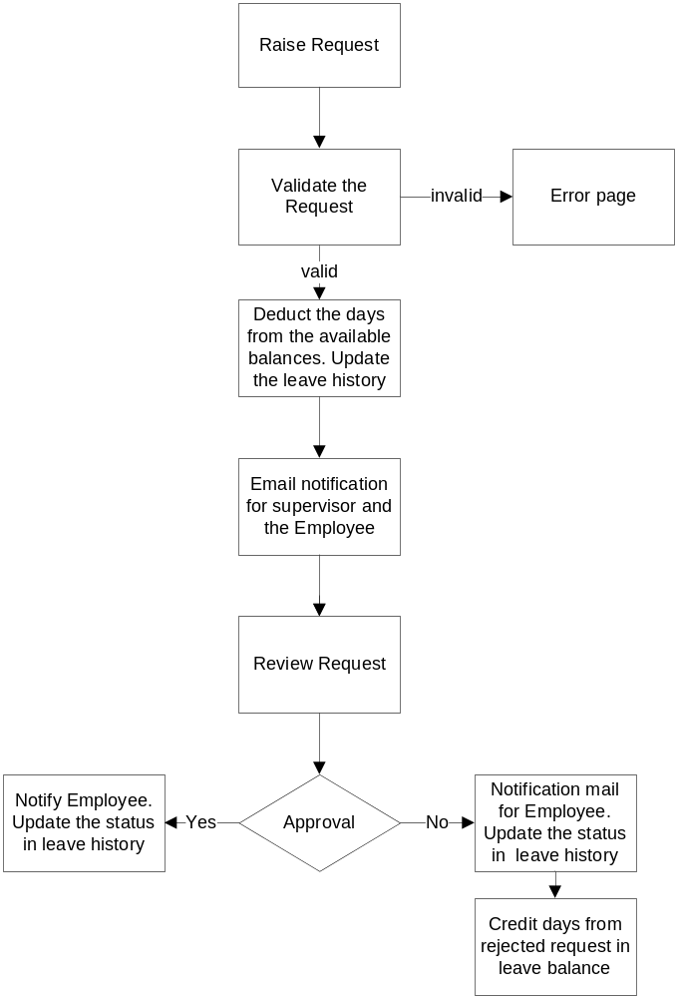

- Technical Design

  - Framework
Struts 2 frame work will be used to develop the application. Struts 2 follows the Model-View-Controller (MVC) design patterns.
Model - Model in Struts 2 is action classes. This contains the business logic.
View – View is the presentation component. This is implemented using jsp files.
Controller – Controller will map the incoming requests to actions.Those mappings are defined by using struts.xml configuration.
  - Database Design
Employee vacation tracker will use MySql database as its repository. DB stores all employee login information and employee leave history.
  - JDBC
Java Database connectivity (API) is used in the new system to connect programs written in Java to the database.
4.4 Web/Application server
Tomcat is used as the web server for the application.

